

I’m taking the liberty of providing this introduction because the description is very long, and not everyone will read it fully.

* **This mod is not designed for beginners starting Victoria 3** or for players without a solid understanding of economic principles, particularly regarding the metals standard and its mechanisms.
* **This mod is complex and challenging to use.** Several mechanics are highly punitive and can be confusing. It may even feel insurmountable or impossible to manage at first. Be warned: it’s possible to trigger an economic and financial crash in your country that might be irrecoverable.
* **For your first game with this mod**, I recommend playing as major powers that already have systems in place to circulate a sufficient quantity of currency. Among countries with central banks, *France, Russia,* and the *USA* are excellent starting choices. *Austria, Spain, China,* and the *Ottoman Empire* are more challenging. Meanwhile, *Japan* and other countries without central banks but with large territories and abundant resources will become interesting options once you’ve mastered the mod. Finally, small European states (e.g., *Netherlands, Belgium, Switzerland*) or resource-poor nations will be extremely difficult—if not impossible—to play successfully. Achieving economic or financial dominance with these countries throughout the game will be virtually unattainable.
* The description below is **not exhaustive and does not serve as a tutorial** but rather as an overview. I’ve tried to include as much detail as possible, but you’ll need to learn by playing. I’ve added numerous tooltips—make sure to read them, as they’ll help explain various mechanics.
* I’m currently testing the mod on a system with an *i5-14600K (no overclock), 32GB DDR5 RAM,* and an *RTX 4070 Ti.* I experienced a 20–30% performance drop compared to vanilla, but it hasn’t hindered gameplay. For more details, refer to the *Compatibility & Performance* section.

**Happy reading!**

I’m back with version 4 of the *Economic and Financial Mod (E&F)*, featuring a major update focused on the financial aspects of the mod. This version also introduces new metallic standards, economic crises, monetary crises, stock market crashes, 40 new types of financial centers, and much more.

The description has been completely reworked and updated for the new version.

Thank you all!

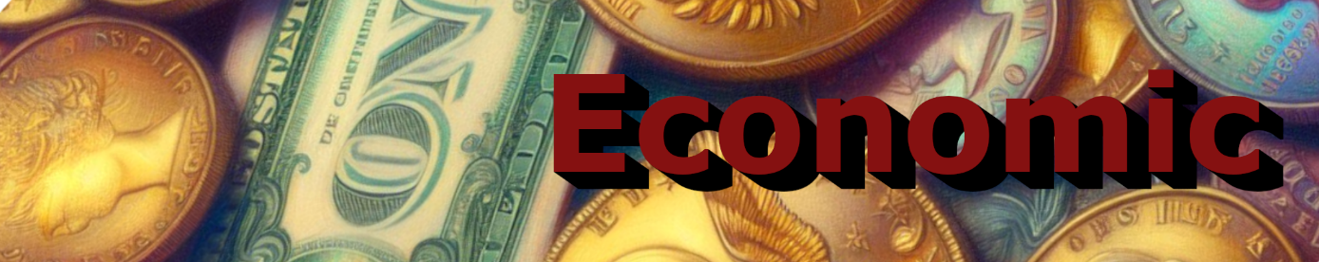

The main building is the **central bank**, which plays a key role in the economy. The central bank produces a specific currency unique to each country or culture and generates bonds.

A central bank is created as soon as you research the **Central Banking** technology. A level 5 central bank will automatically appear in your capital. Its level will then increase in parallel with your GDP (e.g., 10M = level 10, 75M = level 75, etc.).

You cannot manually decrease or increase the level of the central bank: its progression is automatically tied to the growth of your economy.

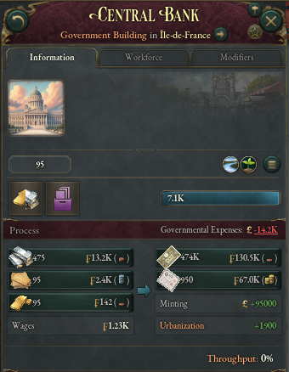



The central bank can be managed through various technologies that allow you to devalue or revalue your currency, take a loan from your central bank, or adjust your currency's parity to a specific type of metal.

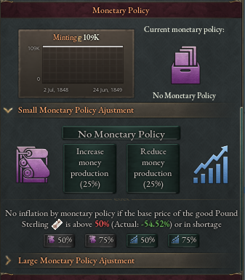

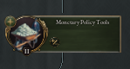

A currency can be pegged to a metal, to a reference currency, or function as a fiat currency. These indexing options depend on the country's available technologies and chosen laws. If you are a major silver producer, a silver standard would be more suitable. Likewise, if you are a significant gold producer, a gold standard would be more appropriate. An ideal middle ground could be a bimetallic standard. The prices of these metals, influenced by global production, affect the value of your reserves. This is especially true for silver, whose price relative to gold directly impacts the value of your reserves.

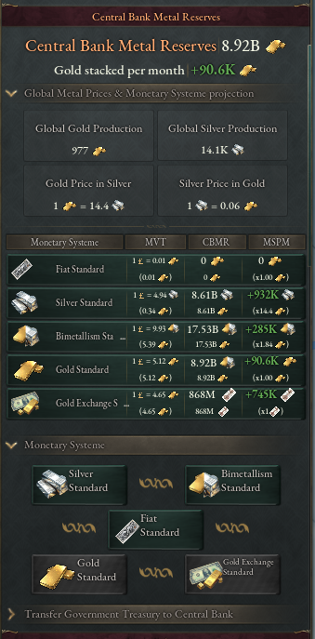

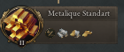

95 different types of currencies are available depending on the country you play. Some countries do not have their own currency; they are assigned a universal currency.

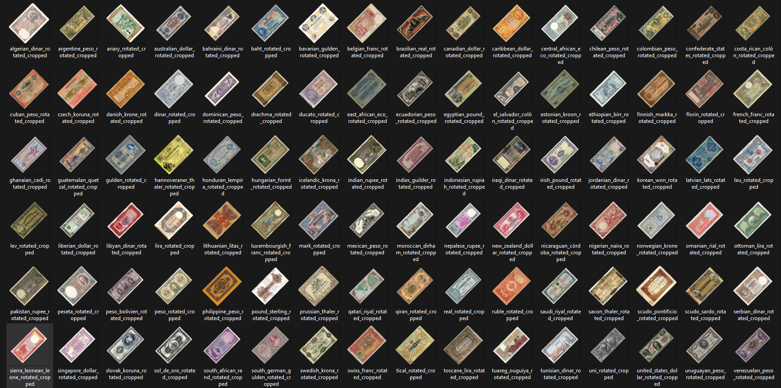

These currencies are used by your buildings and are demanded by the population in urban centers.

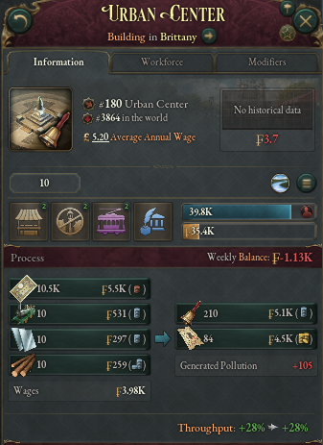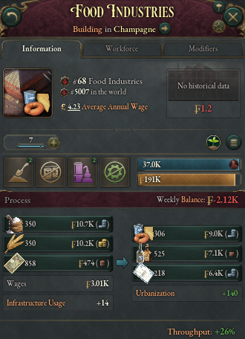

You can take loans from your central bank, paying monthly interest until your debt is fully repaid. A loan exceeding your GDP will result in severe penalties to your country's credit rating, which will increase interest rates.

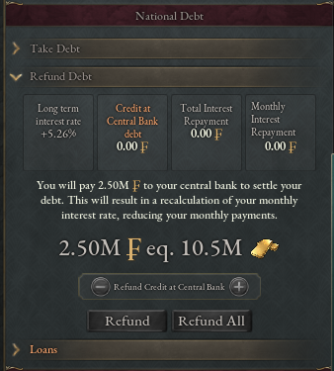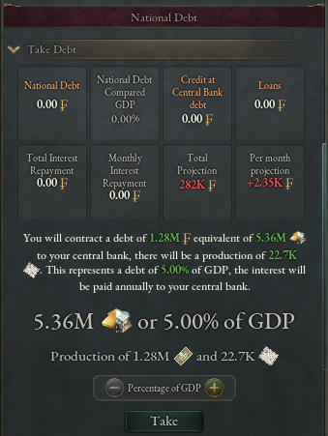

Your country has 4 different interest rates:

* **The domestic bond rate**, which is the standard (vanilla) rate used for the country's budget credit.
* **The base rate percentage**, a rate you have control over. It represents the maximum amount the central bank can lend to private funds/private banks per year. Increasing it will reduce the money lent by your central bank to private funds/private banks.
* 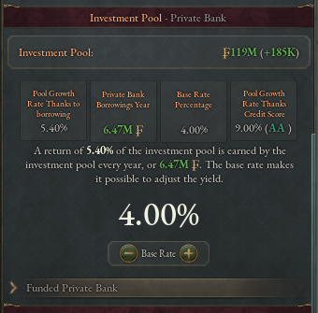**The international bond rate** (long/short), this rate applies when foreign countries lend money to your central bank.

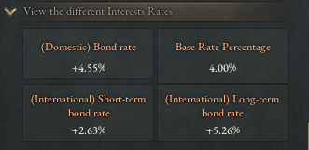

These different rates are influenced by your country's rating. I will revisit this topic in the **Financial** section.

Regarding your currency, you have full control over it:

* **Money supply**, which is composed of the amount of national currency held by your population, the currency held by the investment fund/private banks, the cash reserves of your buildings, and most importantly, the national currency reserves held by your central bank. This is the only money supply you have control over. Additionally, this part can be purchased by foreign countries to stabilize your currency. A fourth component is the currency held by the government, representing the payments the country receives every month and the loans you make to your central bank. This money supply can only be reduced by repaying your debt.
* **National capacity**, which consists of your central bank’s metal reserves, loans made to your central bank by other countries, and metals obtained through your trade routes.

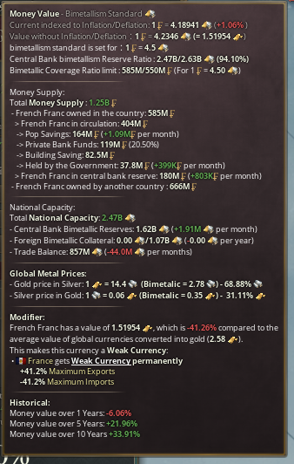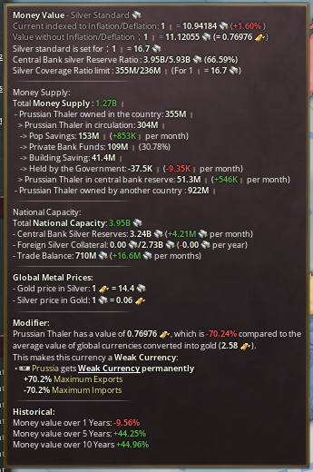

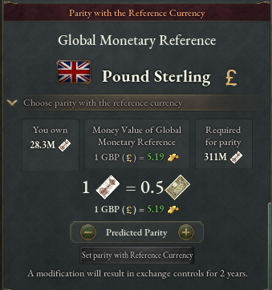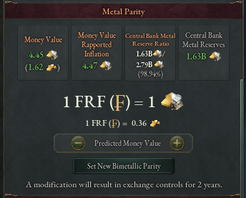 If your currency is indexed to a quantity of metals or a reference currency, you can choose the indexing ratio.

The value of your currency will influence the cost of your imports and exports. The value of your currency is compared to the average of all the currencies from countries that have their market in the world. Based on this, a classification will be assigned to your currency: **Strong currency**, **Balanced currency**, **Weak currency**.

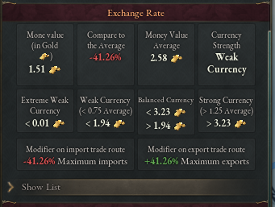 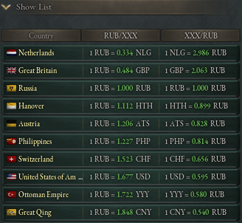

Depending on the strength of your currency, a penalty or bonus will be applied to your import and export routes. If your currency is strong, your imports will cost less, but your exports will yield less. Conversely, if your currency is weak, your exports will yield more, but your imports will be very expensive. All of this is calculated based on your currency's deviation from the average value.

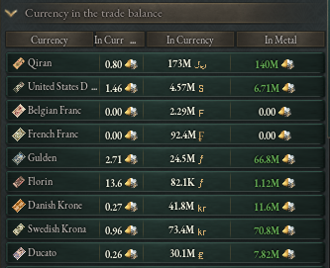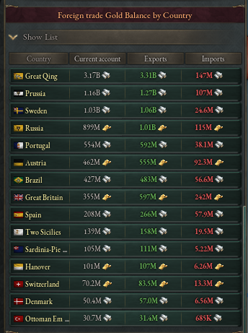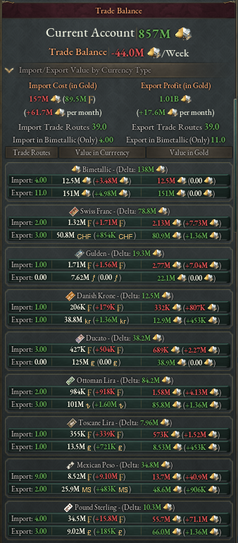

Thanks to this, you will be able to accumulate foreign currencies or, conversely, incur debt in your currency to other countries that will be able to claim gold or silver in exchange for your currency by selling it to your central bank. But you can do the same: for example, if you export goods massively to Great Britain, this will allow you to generate British pounds, which you can then exchange for gold via the FOREX market.

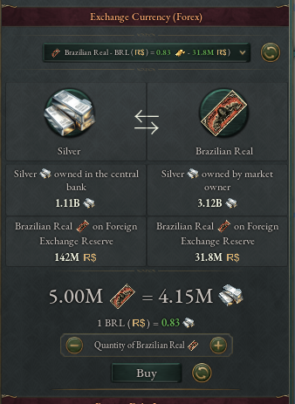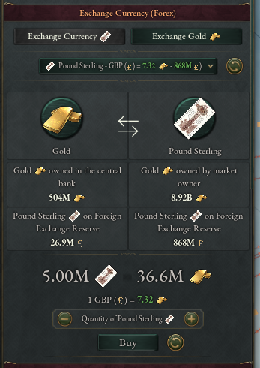

The FOREX allows you to buy or sell a specific currency from the country of your choice. However, you can only sell a currency for gold or silver to the central bank that issues that currency.

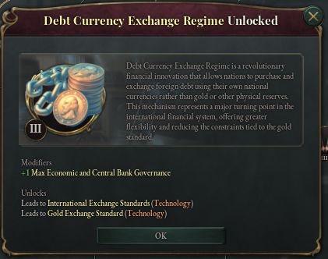

Depending on the technologies unlocked, you can even purchase foreign debt in their currency instead of buying it in metals.

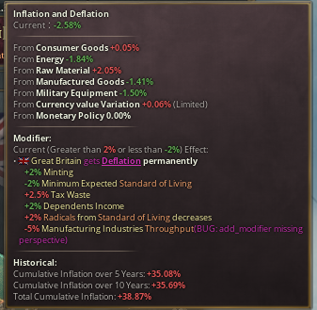  
The value of your currency is also determined by inflation. Inflation is calculated over one year based on the prices of goods in your market, the variation in the value of your currency, or the monetary policies used.

Regarding the different currencies held by your central bank, all these currencies are stored in the state where your central bank is located. This means that if an enemy country seizes your capital’s state, they will be able to loot what is stored there, resulting in a significant generation of infamy. Furthermore, if they fully occupy the state, they will be able to deactivate your central bank for as long as they occupy the state. This will cause the economy of your country to come to a halt, as all buildings in your country require your national currency to function.

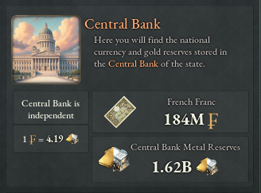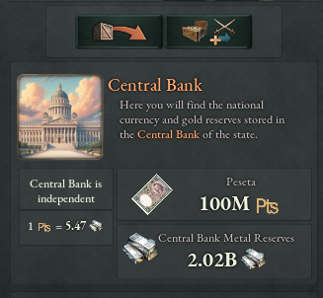

You can view the currency you hold directly in the economic section of the budget panel, or you can check it in the state panel of your capital.

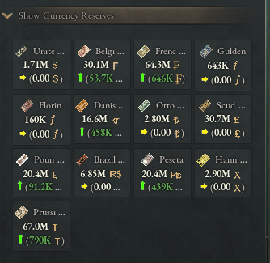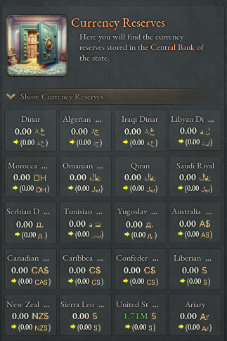

You can also see which countries hold your currency if you wish to repurchase it.

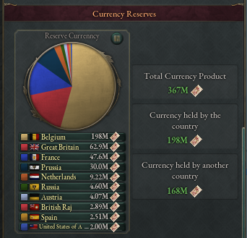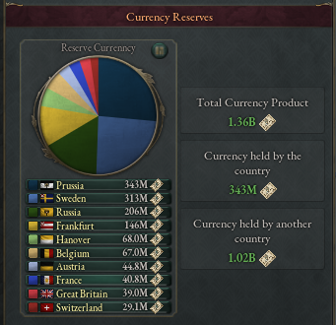

Finally, you can compare your currency to all the currencies circulating in the world.

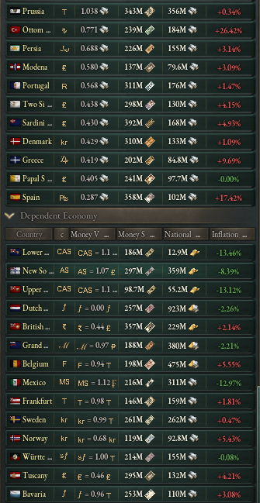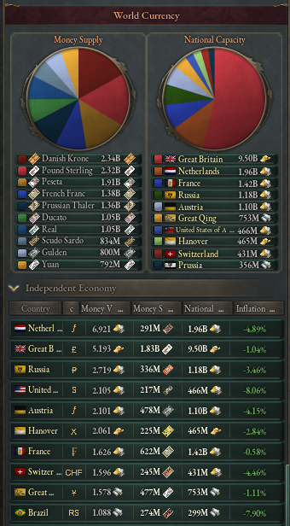

In this section, you will be able to see the value of currencies depending on whether the country that holds them is dependent or independent. Indeed, subject countries or those without their own market have their currency indexed inversely proportional to their GDP to the currency of their suzerain. Furthermore, a number of important features are disabled for subject countries or those that do not have their own market.

As a subject or suzerain, you can track the currencies of your subjects and adjust their parity to decrease or increase their growth.

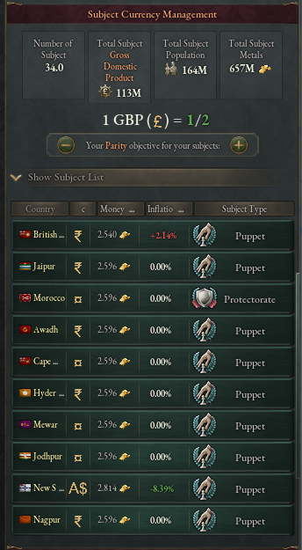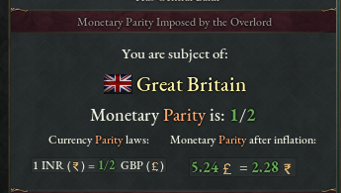

A reference currency will be determined based on the country that holds the largest amount of metals. At the start of the game, Great Britain holds the largest amount of gold, but this can change over time during the game.

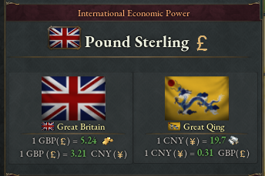

There are 4 out of 5 crises in the economic part:

1. **Country Bankruptcy**: The country's classic bankruptcy (vanilla bankruptcy).
2. **Central Bank Bankruptcy**: This crisis occurs when the amount of metals in your central bank is no longer sufficient compared to the amount of currency produced. Your currency becomes an **Extreme Weak Currency**, meaning a value in gold below 0.001. This results in a complete blockage of all trade routes. When this crisis triggers, all countries in the world holding your currency will sell it back to your central bank, intensifying the crisis. Your country's rating will drop to the minimum of D for 2 years.
3. **Currency Crisis**: This crisis happens when the value of your currency decreases by more than 50% over the course of one year. Like the **Central Bank Bankruptcy**, all countries holding your currency will sell it. Additionally, trade routes will be blocked for 2 years. If your currency does not fall to **Extreme Weak Currency**, you can continue normally. However, if your currency becomes **Extreme Weak Currency**, it will also trigger a **Central Bank Bankruptcy**. These crises can overlap. Your country's rating will drop to the minimum of D for 2 years.
4. **Economic Crisis (Country)**: This crisis occurs when your country's GDP decreases by more than 50% over 1 year. It is the worst economic crisis in the game, with severe consequences. First, the maximum level of your central bank will be reset to level 5. All buildings, both private and public, will suffer a 100% production penalty. All reserves of your currency (pop and private banks) will be reset to zero, and all trade routes in your country will be deactivated. Your country's rating will drop to the minimum of D for 2 years. As with the previous crises, if you have a **Central Bank Bankruptcy** or **Currency Crisis** and your country is heavily dependent on foreign markets, your GDP may collapse, triggering an **Economic Crisis**.

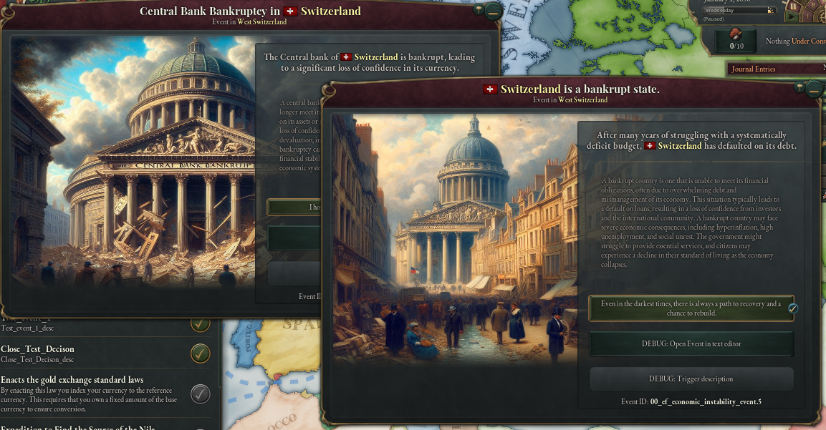

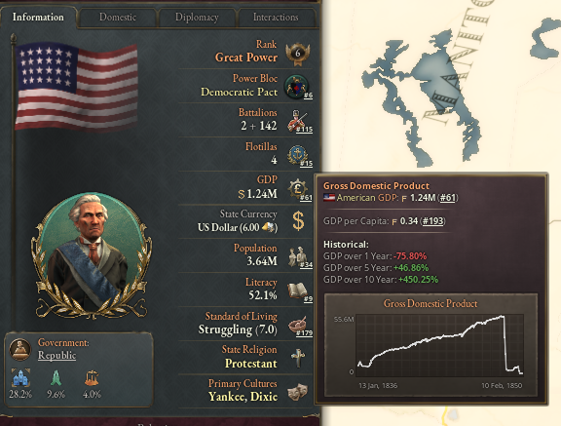

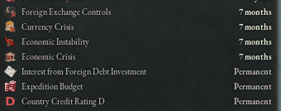

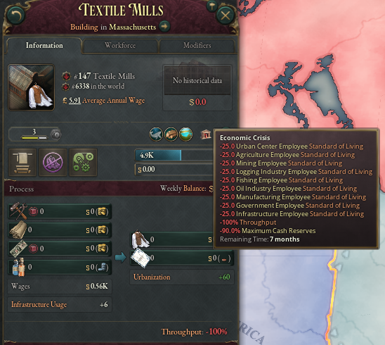

You will understand that different synergies can be used by the player or the AI to cause a country to collapse. For example, you can attack a country, invade its capital, and loot its reserves, which will deactivate its central bank, potentially triggering an economic crisis that will completely destroy its economy. You can do the same by holding a large amount of a country's currency and selling it massively, causing it to drop by 50% in one year and triggering a currency crisis.

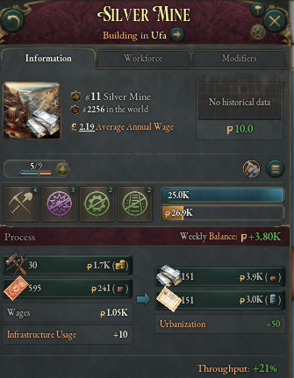

Other feature:

* Addition of silver mines.
* Addition of GDP history, money value, and inflation.

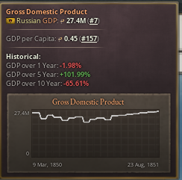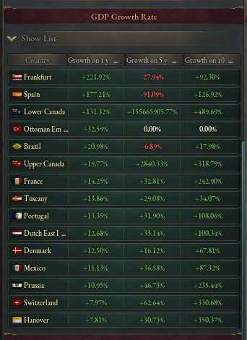



The building in the financial section is the **Financial Center**. There are 43 different types of **Financial Centers**, each defined by a specific location. For example, the **Paris Stock Exchange** will always be in Paris, the **Vienna Stock Exchange** will always be in Vienna, the **Hong Kong Stock Exchange** will always be in Hong Kong, and so on. For countries that do not have a custom financial center, a generic financial center will be assigned.

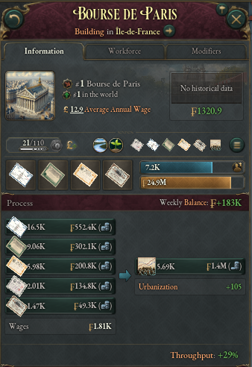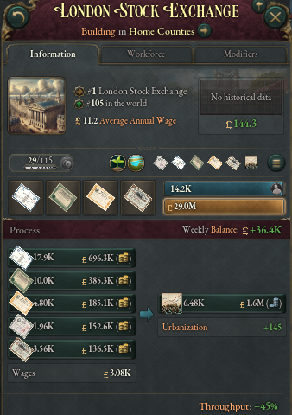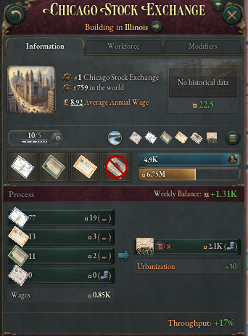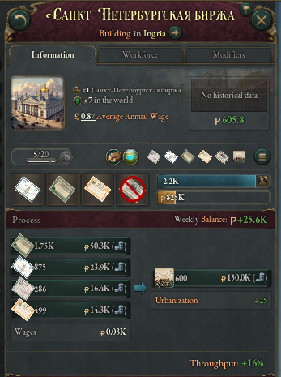

A **financial center** of level 5 appears when the **Financial Center** technology is unlocked. Unlike **central banks**, **financial centers** do not automatically increase their level. Indeed, these buildings have a maximum level that is determined by the country's GDP. As with **central banks**, the level increases every 5 million of GDP (10 million = max level = 10, 75 million = max level = 75). The player cannot increase or decrease the level of these buildings.

**Financial centers** are exceptional buildings that completely deviate from the vanilla building mechanics. In fact, **financial centers** are automatic buildings, and their level does not influence the production or consumption of goods.

**Financial centers consume 5 types of goods and produce 1:**

* **Bond** (always produced by the central bank and always consumed by financial centers)
* **Manufacture stock** (produced by manufactures owned more than 50% by the private sector, such as **Financial District or Manor House**)
* **Agricultural stock** (idem)
* **Mining stock** (idem)
* **Railroad stock** (idem)

They produce **mutual funds** which are consumed in small quantities by the wealthiest populations of the country.

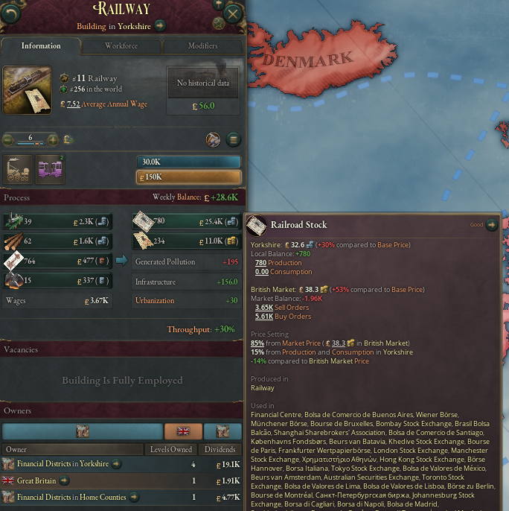

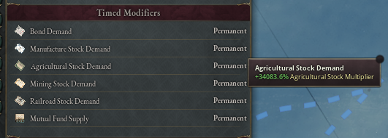**Financial centers** work as follows: a building owned by more than 50% by a **company**, a **Financial District**, or a **Manor House** will start producing a type of stock (PM updated every 6 months). If the quantity of a type of stock is present on the market, the **financial center** will begin consuming it. The purpose of the **financial center** is to maintain the price equilibrium of each type of stock, which is why the building, using modifiers, will calculate the quantity to consume each month to keep the price balanced. The player or the AI cannot interact with this system.

A quantity of financial products can be imported so that the **financial center** consumes them and artificially increases GDP. However, the maximum amount of importable financial products is limited by technologies. Four technologies will allow you to increase the amount of importable financial products, each providing a 25% increase. If the proportion of a financial product is mostly imported, the good will be automatically banned, removing all trade routes for this product.

This system allows the creation of a new type of building: the **Private Construction Sector**. These buildings function in the same way as the vanilla construction sector, but instead of being funded by the state, they produce **manufacture stock**.

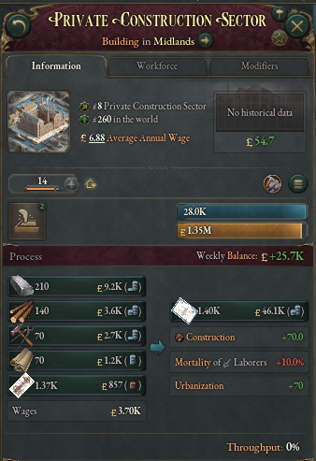

Construction capacity is directly linked to the price of **manufacture stock**. If their price crashes, construction suffers as well. These buildings are automatically constructed by the private sector or investment pool. Furthermore, these buildings appear in proportion to the number of public construction sectors (for example: if you have 25 public construction sectors, then 25 private construction sectors will appear).

Your different financial products have a price, which is determined by various factors, including the price of the goods themselves. Additionally, the different financial products are stored in the same way as currencies, in the state where your **Financial Center** is located. This allows the capitalization of a sector in your country (price x quantity) to be determined, as well as the total capitalization of financial products in your country.

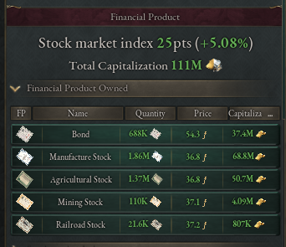 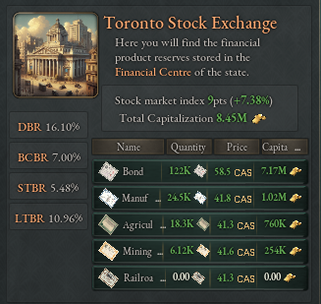

We can compare the different capitalizations of various countries and define a **global financial power**, which will be the country with the highest capitalization. We can also indicate the performance of different countries through their stock index.

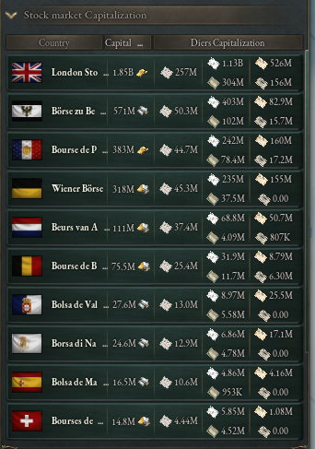 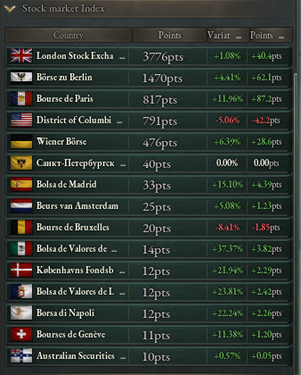

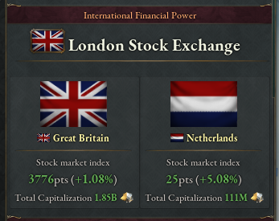

Since we can determine a capitalization that varies up or down based on the price of financial products, we can introduce a new crisis: the **Financial Crash**.

A financial crash is defined by a 50% drop in the country's stock index. This crisis has variable consequences depending on the importance of the private sector in your country. Indeed, only buildings owned by more than 50% by a company, a **financial district**, or a **manor house** will suffer a 50% production penalty, while government-owned buildings will not be penalized. Additionally, 50% of the country’s businesses are destroyed, and the investment pool is emptied. If your country's buildings are predominantly owned by the private sector, an economic crisis could overlap.

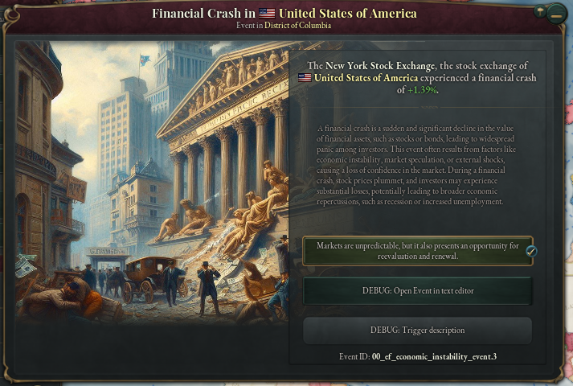

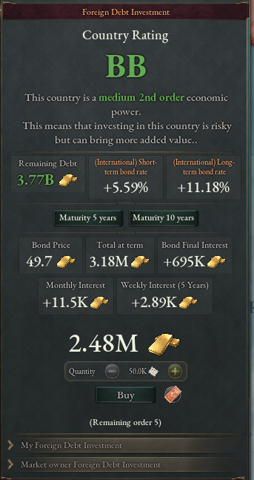Owning a **financial center** allows you to invest in the debt of a foreign country. You can buy 5 debts of 5 years and 5 debts of 10 years. You will receive monthly interest payments, with the capital invested being repaid at the end of the period, provided the country still exists and has not experienced a crisis during that time.

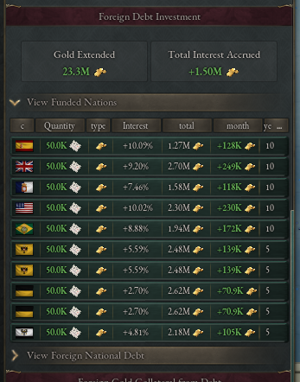

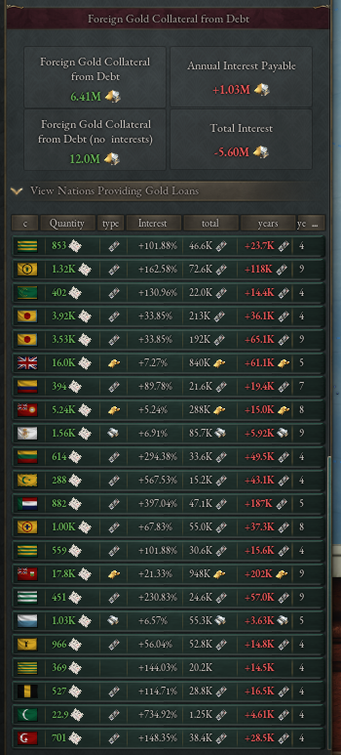

Foreign countries can also invest in your debt. This works the same way as investing in a foreign country's debt, but this time, it's your country issuing debt securities. These foreign countries can buy bonds from your country, in the form of **bonds** with periods of 5 or 10 years. They will receive monthly interest payments, and at the end of the period, the capital invested will be repaid if your country has not gone through a crisis and if its economic situation allows it. This creates a new dynamic for international investment, allowing your country to be financed abroad while maintaining economic relations with other nations.

It is your central bank that pays these interests. The interest rates you pay or that a foreign country pays you depend on the interest rates we discussed earlier. These interest rates are determined by your country's credit rating. This rating is determined by several factors. Based on this rating, the interest rates you pay will be adjusted, reflecting the perceived risk of investing in your country.

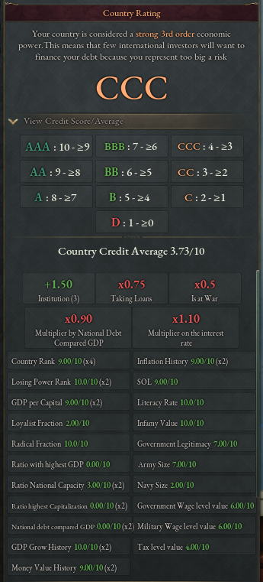

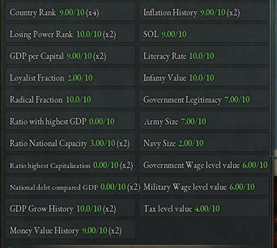

You can also view the debt of other countries to see which ones have a solid economy. By consulting a country's public debt, you can assess its financial stability and ability to repay its loans. A country with well-managed debt and a low debt-to-GDP ratio is generally considered to have a solid economy.

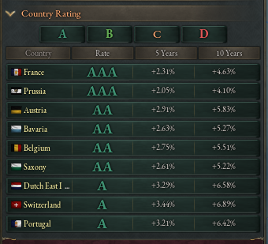 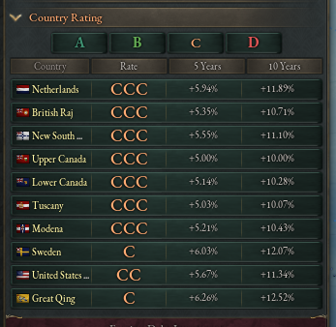

A new institution allows you to gain +0.5 rating points per institution level.

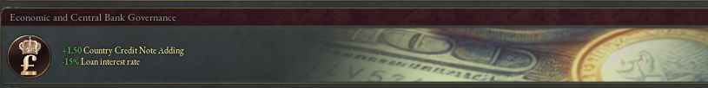

Regarding companies, unlike in the vanilla version, the total number of companies that can be created no longer solely depends on technologies. Now, the maximum number of companies is determined by the level of your financial center (for example, 100 levels of financial center = 100 companies), multiplied by the inverse of the base rate (for example, with a base rate of 8%, this results in an 80% reduction of the maximum level, meaning 20 companies).

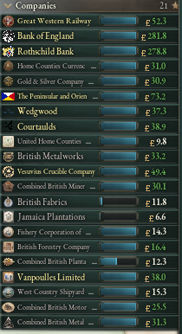

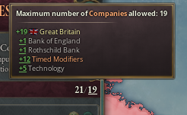

Thanks to the significant increase in the number of possible companies, the creator of the *More Unique Companies* mod allowed me to use the flavor companies from his mod for greater immersion and realism.

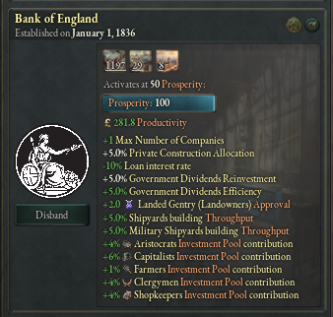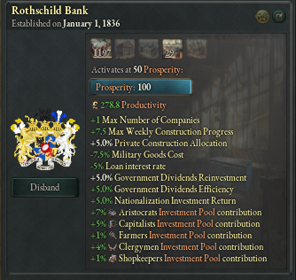

This allowed the addition of private banks as companies which can own *financial center* levels and apply significant bonuses.

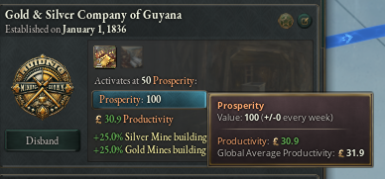Due to the general increase in global productivity thanks to financial centers and the overall improvement in economic efficiency, certain modifications have been made to the company prosperity system. Now, a company must have a productivity greater than 50% of the global productivity to grow. Conversely, if it is below 50%, it will decline. Additionally, the maximum level has been reduced to 100 instead of 200.

In connection with the stockpile (part below), financial centers allow you to buy or sell goods stored in foreign reserves in exchange for the currency of that country, which you can obtain through the trade balance or the forex market.

**Buying goods from foreign reserves:** You can purchase goods stored in foreign reserves in exchange for that country’s currency. This transaction allows you to acquire resources without the need to produce them locally, while also affecting the monetary supply of the concerned country.

**Selling goods from foreign reserves:** You can also sell goods stored in foreign reserves to obtain foreign currency. This action can directly impact the reserves of the selling country and the value of its currency on the market.

This is divided into 2 categories:

* R.M.S.A : Raw Material Supply Agreement -> Market panel

This allows you to purchase raw materials from another country in their national currency.

* M.E.S.A : Military Equipment Supply Agreement -> Market panel

This allows you to purchase military equipment from another country in their national currency.

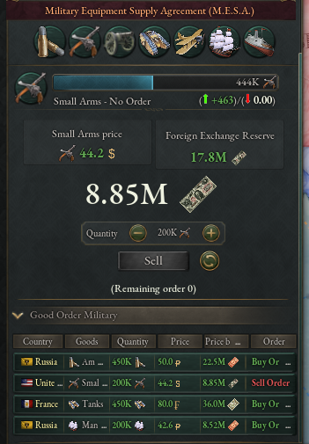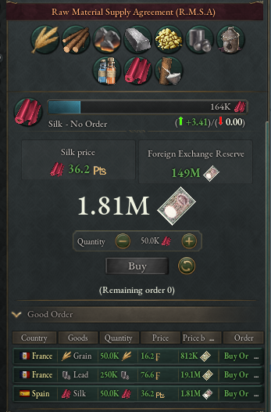



The storage of raw materials and military equipment is essential in the simulation of an economic or financial system.

There are 2 technologies, which are both 2 era 1:

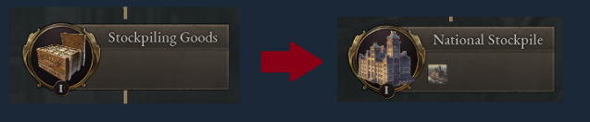

Stockpiling goods allows what I call « stockpile flow ». The stockpile flow, store in the state of your capital the positive surplus of your market. This does not allow you to properly manage storage. You are not able to release assets with this technology.

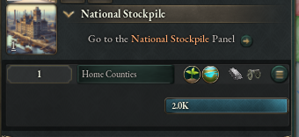

This building does not have a production method because it is managed in the Stockpile tab of the budget panel.

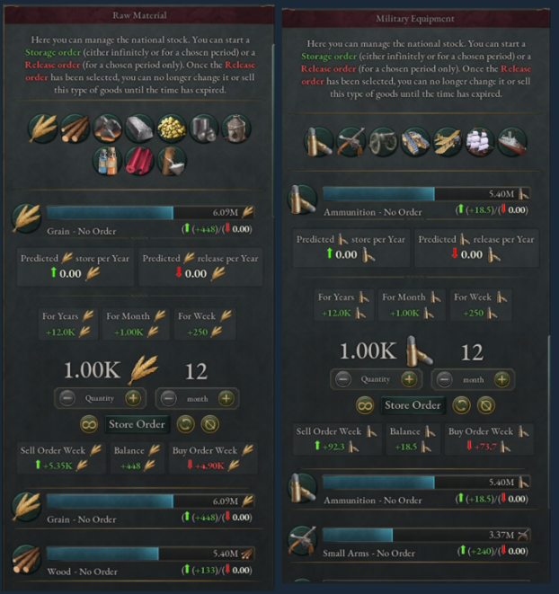

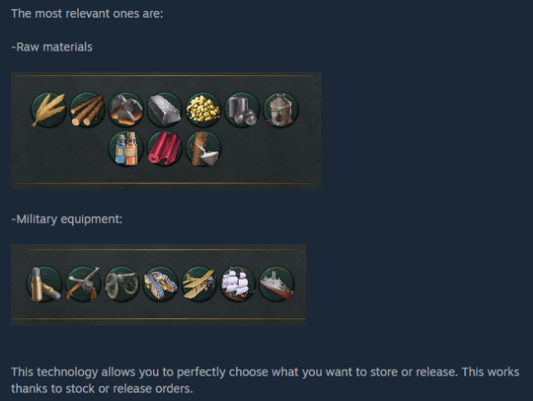

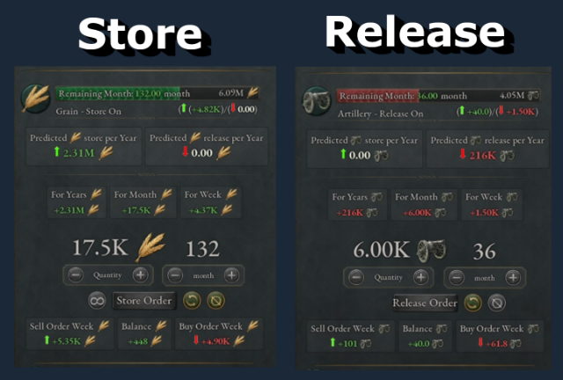

Store order: you can select the quantity and time to launch the order, you can also select the

quantity and launch the infinity mod. In any case, you can cancel your orders at any time.

Release order: you can select the quantity and time to launch the order, you cannot select the

infinity mod. In addition you can no longer sell the good, the predicted quantity is removed from

the stock quantity once the time ends. By the same logic you cannot cancel a release order

when it is launched. This is not the first mod that I have done on the storage of goods, I have on

numerous occasions noticed a big drop in performance when the update of the release was

done every month, this is why the system of The release order is not flexible.

From a performance point of view: with this system I did not see a drop in performance, this was

one of the main points of less work.

From an Al point of view, the Al is capable of making release and stock orders for a period of 2.5

years, the triggering element is the price of a good greater than 75% of the price of the market.

Regarding military equipment, the system is the same but in addition if the mass conscription

law is enacted that automatically activates release order on all military materials if the country

is in war ...

Beyond the different orders, it is in this stockpile that the raw materials and military equipment

that you buy from other countries will be stored. Certain countries have Al strategies which aim

to produce very large quantities of raw materials in order to store them (Russia, USA, etc.),

these countries are therefore preferred targets for purchasing your raw materials if you are a

country without access to the sea and without mining resources. However, you will need the

correct currency value to purchase them.



**Compatibility:**

* Mods that modify the interface are not compatible and may cause E&F tabs to disappear.
* Mods that add new buildings will not be supported by E&F.
* Mods that modify vanilla buildings or production methods for vanilla buildings are completely incompatible with E&F.
* Mods that alter resource placements in the world are entirely incompatible with E&F.
* Mods that modify technologies are partially incompatible with E&F.
* E&F rewrites certain parts of the *defines* file, specific laws (*00_land_reform*), and partially modifies the *30_society* file.
* This list of incompatibilities is not exhaustive. E&F is a sprawling mod that affects many parts of the game. I recommend loading it as a priority.

**Performance:**

* Depending on your hardware, the game may experience increased latency. Generally, E&F is resource-intensive, especially when variable panels or tooltips are open.
* I recommend playing with at least annual auto-saves enabled.
* Crashes are not a common issue with E&F—they simply never happen. *Never.*

**Acknowledgments:**

* Special thanks to the creators of *More Unique Companies* for allowing the use of their company flavor.

**Languages:**

* Currently available only in English. (As promised for over a year, translations are coming soon.)

**Tutorials, FAQ, Discord:**

* I’m aware that this mod can be difficult to master, so I’ll soon create tutorials on Discord and YouTube.
* Feel free to join the Discord to ask questions and share your suggestions.

[img]https://i.imgur.com/hifxev2.png[/img]

[img]https://i.imgur.com/R98R201.png[/img]

[img]https://i.imgur.com/Apuk3Kh.png[/img]

[img]https://i.imgur.com/aL3RtsD.png[/img]

[img]https://i.imgur.com/aXXQm31.png[/img]

[img]https://i.imgur.com/OJUDlzD.png[/img]

[img]https://i.imgur.com/RBuwqOY.png[/img]

[img]https://i.imgur.com/LafAqUE.png[/img]

[img]https://i.imgur.com/cBpqiet.png[/img]

[img]https://i.imgur.com/3cRfX7P.png[/img]

[img]https://i.imgur.com/wMqdwD5.png[/img]

[img]https://i.imgur.com/4txbGe6.png[/img]

[img]https://i.imgur.com/Mqtr4yW.png[/img]

[img]https://i.imgur.com/hrr9xSh.png[/img]

[img]https://i.imgur.com/Mdvnmz2.png[/img]

[img]https://i.imgur.com/3IiJHDE.png[/img]

[img]https://i.imgur.com/Qavpp76.png[/img]

[img]https://i.imgur.com/tPFFpee.png[/img]

[img]https://i.imgur.com/gIN2Rkm.png[/img]

[img]https://i.imgur.com/LUbsn53.png[/img]

[img]https://i.imgur.com/OPl6Grw.png[/img]

[img]https://i.imgur.com/57Acmdx.png[/img]

[img]https://i.imgur.com/tDO61qd.png[/img]

[img]https://i.imgur.com/E0u3ecc.png[/img]

[img]https://i.imgur.com/78Dxau1.png[/img]

[img]https://i.imgur.com/k9LsEKB.png[/img]

[img]https://i.imgur.com/WwttKpQ.png[/img]

[img]https://i.imgur.com/tpsaCJx.png[/img]

[img]https://i.imgur.com/7c5yPfx.png[/img]

[img]https://i.imgur.com/SJpxjMD.png[/img]

[img]https://i.imgur.com/watOstN.png[/img]

[img]https://i.imgur.com/cT78oQJ.png[/img]

[img]https://i.imgur.com/QuYVhvQ.png[/img]

[img]https://i.imgur.com/BwtooJn.png[/img]

[img]https://i.imgur.com/9053EkB.png[/img]

[img]https://i.imgur.com/p2zW2D7.png[/img]

[img]https://i.imgur.com/lRR3RyO.png[/img]

[img]https://i.imgur.com/1vNRfNX.png[/img]

[img]https://i.imgur.com/1naAWA0.png[/img]

[img]https://i.imgur.com/rWTayW4.png[/img]

[img]https://i.imgur.com/UyerOhn.png[/img]

[img]https://i.imgur.com/CrGS7Bv.png[/img]

[img]https://i.imgur.com/45WKPoS.png[/img]

[img]https://i.imgur.com/mTqC9mD.png[/img]

[img]https://i.imgur.com/DI79ZtA.png[/img]

[img]https://i.imgur.com/EcvhYB5.png[/img]

[img]https://i.imgur.com/BBPVTYq.png[/img]

[img]https://i.imgur.com/7YWAo3O.png[/img]

[img]https://i.imgur.com/nXTdnAy.png[/img]

[img]https://i.imgur.com/Ndk0Die.png[/img]

[img]https://i.imgur.com/1m121kY.png[/img]

[img]https://i.imgur.com/0HbIVmy.png[/img]

[img]https://i.imgur.com/n6LSnzL.png[/img]

[img]https://i.imgur.com/3j1jglG.png[/img]

[img]https://i.imgur.com/3nK4aRi.png[/img]

DISCORD: https://discord.gg/PPwYGq5N89

Buymeacoffee: https://www.buymeacoffee.com/ebtx